Sorting Algorithms Set 1 **(Last date to Submit: 11/ Apr/2020)**

1. Bubble Sort

Source Code:

#include<iostream>

using namespace std;

int main()

{

int a[50], n, i, j, temp;

cout<<"Enter the size of array: \n";

cin>>n;

cout<<"Enter the array elements: \n";

for(i = 0; i < n; ++i)

{

cin>>a[i];

}

for(i = 1; i < n; ++i)

{

for(j = 0; j < (n - i); ++j)

if(a[j] > a[j + 1])

{

temp = a[j];

a[j] = a[j + 1];

a[j + 1] = temp;

}

}

cout<<"Sorted array: \n";

for(i = 0; i < n; ++i)

{

cout<<" "<<a[i];

}

return 0;

}

**OUTPUT**

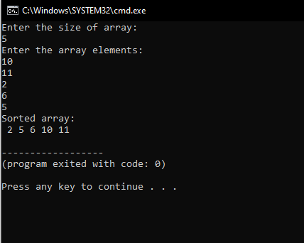

1. Selection Sort

Source Code:

#include<iostream>

using namespace std;

int main()

{

int i,j,n,loc,temp,min,a[30];

cout<<"Enter the number of elements: \n";

cin>>n;

cout<<"Enter the elements \n";

for(i=0;i<n;i++)

{

cin>>a[i];

}

for(i=0;i<n-1;i++)

{

min=a[i];

loc=i;

for(j=i+1;j<n;j++)

{

if(min>a[j])

{

min=a[j];

loc=j;

}

}

temp=a[i];

a[i]=a[loc];

a[loc]=temp;

}

cout<<"\nSorted numbers are: \n";

for(i=0;i<n;i++)

{

cout<<a[i]<<" ";

}

return 0;

}

**OUTPUT**

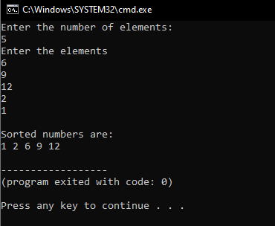

1. Insertion Sort

Source Code:

#include<iostream>

using namespace std;

int main()

{

int i, j, n, temp, a[30];

cout<<"Enter the number of elements \n";

cin>>n;

cout<<"Enter the elements \n";

for(i = 0; i < n; i++)

{

cin>>a[i];

}

for(i=1;i<=n-1;i++)

{

temp=a[i];

j = i - 1;

while((temp<a[j])&&(j>=0))

{

a[j + 1] = a[j];

j = j - 1;

}

a[j+1]=temp;

}

cout<<"Sorted Numbers: \n";

for(i=0;i<n;i++)

{

cout<<a[i]<<" ";

}

return 0;

}

**OUTPUT**

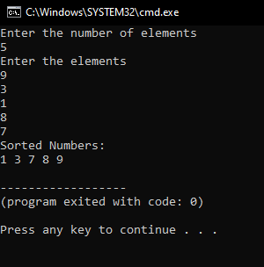

[**https://github.com/harinarayanank/Competitive-Lab**](https://github.com/harinarayanank/Competitive-Lab/tree/master/Sorting%20Algorithms%20Set%201)